**Investigating 1**

The following is taken from a classical piece of research conducted by Sir Frederick Gowland Hopkins. Study the information below then answer the questions that follow:

Sir Frederick took two sets of young rats – 8 in each set – and fed them both a diet consisting of purified casein (protein), starch, sucrose, mineral salts, lard and water. The rats in Set A were also given 3 mL of milk every day for 18 days. After this time, the milk was taken away from the rats in Set A and was given to the rats in Set B. This continued until the end of the experiment. Sir Frederick obtained the following data:

|  |  |  |
| --- | --- | --- |
|  | Average Mass of Rats (g) | |
| Day | SET A | SET B |
| 0 | 45 milk added | 46 no milk given |
| 3 | 50 | 50 |
| 6 | 57 | 52 |
| 9 | 65 | 52 |
| 12 | 70 | 53 |
| 18 | 74 milk stopped | 53 milk added |
| 21 | 78 | 56 |
| 24 | 80 | 60 |
| 27 | 80 | 72 |
| 30 | 81 | 78 |
| 33 | 82 | 80 |
| 36 | 80 | 84 |
| 39 | 77 | 86 |
| 42 | 73 | 89 |

1. What problem was Sir Frederick’s experiment trying to solve?
2. What hypothesis was the experiment designed to test?

Graph both sets of data on the grid supplied below.

1. In the experiment, which variable (milk or body mass) is the
2. Dependent? _______________________________________
3. Independent? _______________________________________
4. Do the results support the hypothesis you gave in part (b)? Explain your answer.
5. What conclusion can you draw from the results of this experiment?

**Investigating 2**

Read the article below from *The West Australian* newspaper (Wednesday, April 21, 2004) and then answer the questions on the following pages. The paragraphs in the article are numbered and some questions refer to specific paragraphs.

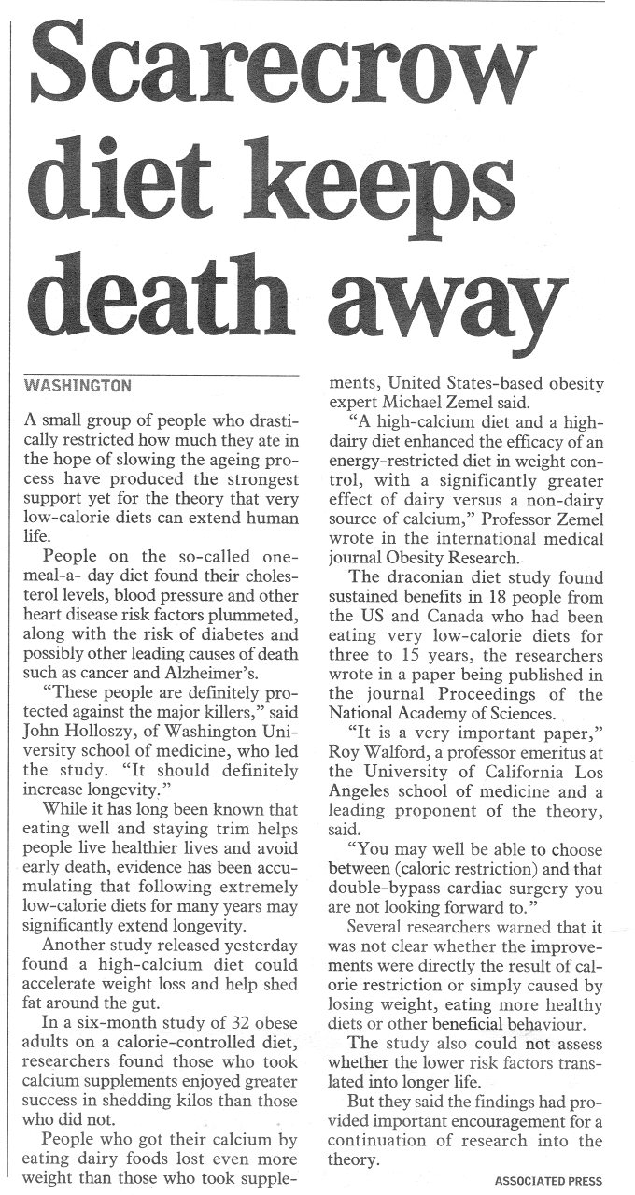

6

4

14

13

12

11

10

9

8

1

2

7

5

3

1. The article mentions the results of two studies investigating the effects of diet. Write an appropriate hypothesis for each study.
2. Two perceived benefits of ‘very low-calorie diets’ are lower blood cholesterol and lower blood pressure (Paragraph 2). Explain why a decrease in each of these factors helps protect against cardiovascular disease.

The next six questions refer only to the study investigating calcium supplements (paragraphs 6-8)

1. Identify the independent variable for this study.
2. What is the dependent variable in this study?
3. This study had three experimental groups. Identify the different diet treatment given to each group.
4. List three variables that were controlled in this study. These variables must be mentioned in the article.
5. Identify one other variable that should have been controlled and explain the consequences of not controlling this variable.
6. The final two paragraphs (13 & 14) suggest that more research is necessary. Why is it necessary to repeat any scientific investigation?

**Investigating 3**

A group of researchers wanted to compare the ability of two different treatments for relieving tension headache pain. They set up the following investigation that ran over a six month period.

The 60 volunteers were divided into three groups

Group A 20 people Took a tablet containing 500 mg of paracetamol

Group B 20 people Took a tablet containing 200 mg of ibuprofen

Group C 20 people Took a tablet with no active ingredient

The volunteers took their respective tablets each time they suffered from a headache. At fixed times after the start to the treatment each volunteer recorded the severity of the headache using the following rating scale:

0 = no headache 1-2 = mild headache 3-4 = moderate headache 5 = severe headache

The results for each group were average and are tabulated below:

|  |  |  |  |
| --- | --- | --- | --- |
|  | Severity of Headache (average) | | |
| Minutes after taking tablet | Group A | Group B | Group C |
| 0 | 3.70 | 4.00 | 3.60 |
| 5 | 3.80 | 3.40 | 3.65 |
| 10 | 3.00 | 3.15 | 3.10 |
| 20 | 3.20 | 2.75 | 3.40 |
| 45 | 2.50 | 2.25 | 3.00 |
| 120 | 2.10 | 1.80 | 2.60 |

1. Graph this data
2. From the graph you have drawn, which treatment seems to give the most rapid relief?
3. For Group B, how long after taking the tablet did it take for the headache to be reduced to a rating of 2?
4. In this experiment what was the dependent variable?
5. What was the purpose of Group C?
6. List three considerations the researchers would have needed to make in selecting the sample of volunteers so that their test could be regarded as valid.
7. One variable in this experiment that was difficult to control was the severity of the pain experience by each person before experiment began. How was this problem overcome?
8. In Group A and Group C the severity of the head ache dropped significantly between 5 and 10 minutes, before rising again. This could be due to the placebo effect. Describe this effect